Practical 8
Problem Definition
Design the database for StudentHub with students, events and registrations. Create PHP database connection using MYSQL statements.
Code:-
Db.php:-
<?php
$host = "localhost";
$dbname = "studenthub";
$username = "root";
$password = "";

try {
$pdo = new PDO(
"mysql:host=$host;dbname=$dbname;charset=utf8mb4",
$username,
$password
);

$pdo->setAttribute(
PDO::ATTR_ERRMODE,
PDO::ERRMODE_EXCEPTION
);

$pdo->setAttribute(
PDO::ATTR_DEFAULT_FETCH_MODE,
PDO::FETCH_ASSOC
);

} catch (PDOException $e) {
die("Database connection failed.");
}
?>
Test_connection.php:-
<?php
require "db.php";

echo "StudentHub database connected successfully!";
?>
Screenshot:-


Insert_student.php:-
<?php
require "db.php";

$sql = "INSERT INTO students (name, email, password, course)
VALUES (:name, :email, :password, :course)";

$stmt = $pdo->prepare($sql);

$stmt->execute([
":name" => "Akshay Kumar",
":email" => "akki" . time() . "@gmail.com",
":password" => password_hash("Akshay@123", PASSWORD_DEFAULT),
":course" => "CSE"
]);

echo "Student inserted successfully!";
?>
Screenshot:-

View_students.php:-
<?php
require "db.php";

$stmt = $pdo->prepare(
"SELECT student_id, name, email, course FROM students"
);

$stmt->execute();
$students = $stmt->fetchAll();
?>

<!DOCTYPE html>
<html>
<head>
<title>StudentHub Students</title>
</head>
<body>
<h2>Student List</h2>

<table border="1" cellpadding="10">
<tr>
<th>ID</th>
<th>Name</th>
<th>Email</th>
<th>Course</th>
</tr>

<?php foreach ($students as $student): ?>
<tr>
<td><?= htmlspecialchars((string)$student["student_id"]) ?></td>
<td><?= htmlspecialchars($student["name"]) ?></td>
<td><?= htmlspecialchars($student["email"]) ?></td>
<td><?= htmlspecialchars($student["course"] ?? "") ?></td>
</tr>
<?php endforeach; ?>
</table>
</body>
</html>
Screenshot:-
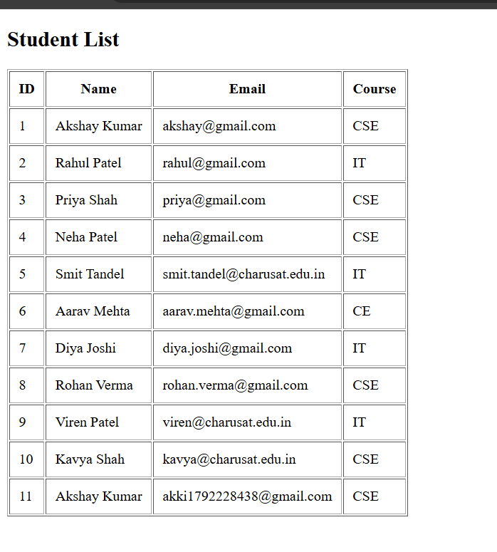
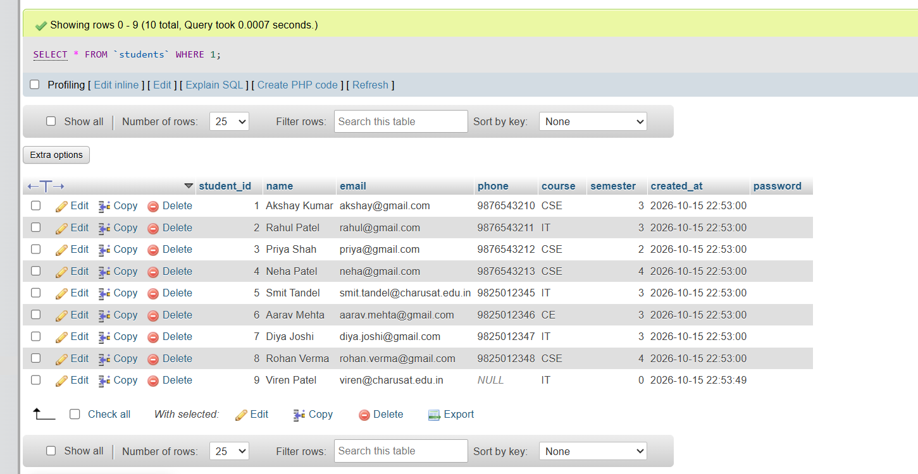
Key Questions:-
1. Is the schema normalized properly?
Yes. The StudentHub database is reasonably normalized because student details, event details, and registration details are stored in separate tables. This reduces data duplication and improves data consistency. The registrations table connects students and events through foreign keys.
2. Are primary keys and foreign keys correctly defined?
Yes. The students table uses student_id as its primary key, the events table uses event_id, and the registrations table uses registration_id. The student_id and event_id columns in registrations are foreign keys that maintain referential integrity. A unique constraint prevents duplicate registrations for the same event.
3. Is the database connection handled securely?
Yes, the PHP database connection uses PDO and exception handling. Prepared statements help prevent SQL injection, and password_hash() securely hashes passwords before storage. Database credentials should be protected, detailed database errors should not be displayed to users in production, and a dedicated database account with limited privileges should be used instead of the default root account.

